JAVA Notes LAB 4
Param Nainani
590014818

Code 1:
- Create an interface Shape with methods to calculate area and perimeter. Implement this interface in classes Circle, Rectangle, and Triangle. Write a Java program to create objects of these classes and display their area and perimeter.

Sol:-
interface Shape {
void area();
void perimeter();
}

class Circle implements Shape {
double radius = 10;

@Override
public void area() {
double a = Math.PI * radius * radius;
System.out.println("Area of Circle: " + a);
}

@Override
public void perimeter() {
double p = 2 * Math.PI * radius;
System.out.println("Perimeter of Circle: " + p);
}
}

class Rectangle implements Shape {
double l = 10;
double b = 20;

@Override
public void area() {
double a = l * b;
System.out.println("Area of Rectangle: " + a);
}

@Override
public void perimeter() {
double p = 2 * (l + b);
System.out.println("Perimeter of Rectangle: " + p);
}
}

class Triangle implements Shape {
double A = 4;
double B = 5;
double C = 6;

@Override
public void perimeter() {
double p = A + B + C;
System.out.println("Perimeter of Triangle: " + p);
}

@Override
public void area() {
double s = (A + B + C) / 2.0;
double a = Math.sqrt(s * (s - A) * (s - B) * (s - C));
System.out.println("Area of Triangle: " + a);
}
}

class AP {
public static void main(String[] args) {
Shape c1 = new Circle();
Shape r1 = new Rectangle();
Shape t1 = new Triangle();

c1.area();
c1.perimeter();

r1.area();
r1.perimeter();

t1.area();
t1.perimeter();
}
}

Output:-
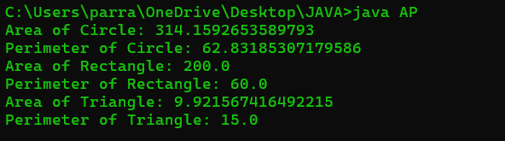

Code2:-
- Define an interface BankAccount with methods for deposit, withdrawal, and balance inquiry. Implement this interface in classes SavingsAccount and CurrentAccount with appropriate constraints, and demonstrate their working using a main class.

Sol:-
interface BankAcc
{
void deposit(double amount);
void withdraw(double amount);
void inquiry();
}

class Savings implements BankAcc
{
double bal = 0;

@Override
public void deposit(double amount)
{
if (amount > 1000){
bal = bal + amount;
System.out.println("Money Deposited, Balance Is:" + bal);
}
else
{
System.out.println("Money Could not be Deposited (amount too low), Balance Is:" + bal);
}
}
@Override
public void withdraw(double amount)
{
if (amount <= bal){
bal = bal - amount;
System.out.println("Money Withdrawn, Remaining Balance Is:" + bal);
}
else
{
System.out.println("Insufficient Balance");
}
}
@Override
public void inquiry()
{
System.out.println("Your current Balance Is:" + bal);
}
}

class Current implements BankAcc
{
double bal = 3000;

@Override
public void deposit(double amount)
{
if (amount > 10000) {
bal = bal + amount;
System.out.println("Money Deposited, Balance Is:" + bal);
}
else
{
System.out.println("Money Not Deposited (amt too low for current acc), Balance Is:" + bal);
}
}

@Override
public void withdraw(double amount)
{
if (amount <= bal){
bal = bal - amount;
System.out.println("Money Withdrawn, Remaining Balance Is:" + bal);
}
else
{
System.out.println("Insufficient Balance");
}
}

@Override
public void inquiry()
{
if(bal<5000){
System.out.println("Your current Balance Is:" + bal + " and it is below minmimum balance of 5000");
}
else
{
System.out.println("Your current Balance Is:" + bal);
}
}
}

class Acc
{
public static void main(String ar[])
{
BankAcc c1 = new Current();
BankAcc s1 = new Savings();

s1.deposit(500);

s1.deposit(10001);
s1.withdraw(4000);
s1.inquiry();

c1.deposit(12000);
c1.withdraw(14000);
c1.inquiry();

c1.deposit(1000);
}
}

Output:-
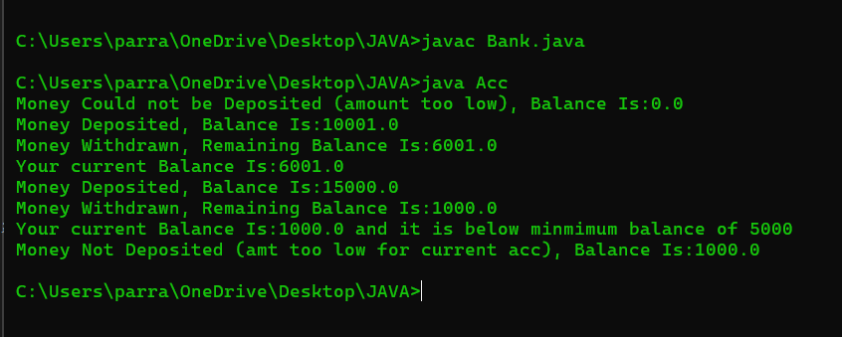

Code 3:-
- Create an interface PaymentMethod with a method for making payment. Implement this interface in classes such as CreditCardPayment, UPIPayment, and NetBankingPayment. Write a program that processes payments using interface references.

Sol:-
interface PaymentMethod
{
void payment(double amount);
}

class CCP implements PaymentMethod
{
double bal = 10000;
public void payment(double amount)
{
bal = bal - amount;
System.out.println("Amount Deducted Remaining Balance Is:"+bal+" Method: Credit Card");
}
}

class UPI implements PaymentMethod
{
double bal = 10000;
public void payment(double amount)
{
bal = bal - amount;
System.out.println("Amount Deducted Remaining Balance Is:"+bal+" Method: UPI");

}
}

class NBP implements PaymentMethod
{
double bal = 10000;
public void payment(double amount)
{
bal = bal - amount;
System.out.println("Amount Deducted Remaining Balance Is:"+bal+" Method: Net Banking");
}
}

class Processor
{
public static void main(String ar[])
{
PaymentMethod c1 = new CCP();
PaymentMethod u1 = new UPI();
PaymentMethod n1 = new NBP();

c1.payment(5000);
u1.payment(2000);
n1.payment(10000);

}
}

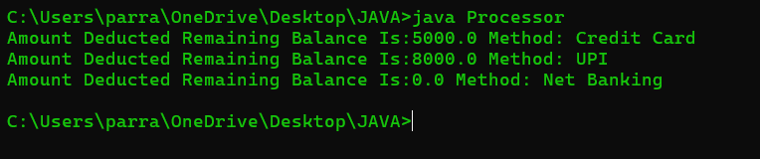
Output:-

Code 4:-
- Create two interfaces, Switchable and Connectable, with methods to turn devices on/off and connect to Wi-Fi respectively. Implement both interfaces in classes SmartLight and SmartFan, and write a program to control these devices using interface-based references.

Sol:-

interface Switchable
{
void OnOff(Boolean status);
}

interface Connectable
{
void wifi(Boolean connect);
}

class SmartLight implements Switchable,Connectable
{

@Override
public void OnOff(Boolean status){
if(status == true)
{
System.out.println("Light is ON");
}
else
{
System.out.println("Light is Off");
}
}
@Override
public void wifi(Boolean connect){
if(connect==true)
{
System.out.println("Light is connected to Wifi");
}
else
{
System.out.println("Light is not connected to Wifi");
}
}
}

class SmartFan implements Switchable,Connectable
{
@Override
public void OnOff(Boolean status){
if(status == true)
{
System.out.println("Fan is ON");
}
else
{
System.out.println("Fan is Off");
}
}

@Override
public void wifi(Boolean connect){
if(connect==true)
{
System.out.println("Fan is connected to Wifi");
}
else
{
System.out.println("Fan is not connected to Wifi");
}
}
}

class implement
{
public static void main(String ar[])
{
SmartLight l1 = new SmartLight();
SmartFan f1 = new SmartFan();

l1.OnOff(true);
l1.wifi(false);
f1.OnOff(false);
f1.wifi(true);
}
}

Output:-
